 |  | Key Terms, People, and Beliefs | Key Terms, People, and Beliefs | Key Terms, People, and Beliefs
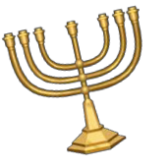  Judaism | Region / civilization  where it began and flourished:  Founder: Sacred text: | Exodus:  Moses:  Ten Commandments: | Diaspora:  Where do Jews worship?  Who are Jewish spiritual leaders? | What are the two covenants of the Hebrew tradition?
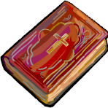  Christianity | Region / civilization  where it began and flourished:  Founder:  Sacred Text: | Gospels:  Saint Paul: | Messiah:  New Testament: | Where do Christians worship?  Who are Christian spiritual leaders?
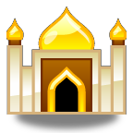  Islam | Region / civilization  where it began and flourished:  Founder: Sacred text: | Fiver Pillars of Islam:  1.  2.  3.  4.  5. | Hijra:  Dome of the Rock:  Caliphs: | Why was there a division of Islam into Sunni and Shi’a sects?  Where do Muslims worship?  Who are Muslim spiritual leaders?
Belief Systems/ Religions/ Philosophies:
Complete the chart using vocabulary words. Define all vocabulary terms ☺

- How did Christianity develop from Judaism?

___________________________________________________________________________________________________________________________________
___________________________________________________________________________________________________________________________________
___________________________________________________________________________________________________________________________________

- How does the Christian Bible link Judaism to Christianity?
___________________________________________________________________________________________________________________________________
___________________________________________________________________________________________________________________________________
___________________________________________________________________________________________________________________________________

- How are the Ten Commandments and the 5 Pillars of Islam similar?
___________________________________________________________________________________________________________________________________
___________________________________________________________________________________________________________________________________
___________________________________________________________________________________________________________________________________

- How was Islam able to spread?
___________________________________________________________________________________________________________________________________
___________________________________________________________________________________________________________________________________
___________________________________________________________________________________________________________________________________

- What were the important contributions of the Abbasid/Muslim Golden Age?
___________________________________________________________________________________________________________________________________
___________________________________________________________________________________________________________________________________
___________________________________________________________________________________________________________________________________
___________________________________________________________________________________________________________________________________
___________________________________________________________________________________________________________________________________
___________________________________________________________________________________________________________________________________

